Match the following terms to the correct example:
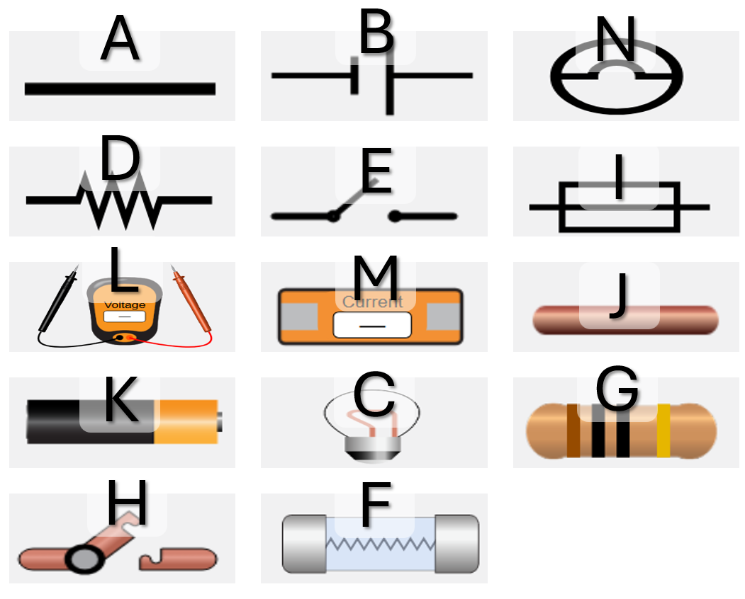
Word Bank: Light Bulb, Cell, Resistor, Voltmeter, Wire, Fuse, Ammeter, Switch
1. A _________________________
2. B _________________________
3. C _________________________
4. D _________________________
5. E _________________________
6. F _________________________
7. G _________________________
8. H _________________________
9. I _________________________
10. J _________________________
11. K _________________________
12. L _________________________
13. M _________________________
14. N _________________________

